**Software Requirement Specification (SRS)**

Of

**Assets Management & Maintenance module**

For Implementation of

**Campus Management Software**

at

**World Skill Center (WSC)**

****

**Sustainable Outreach And Universal**

**Leadership (SOUL) Limited**

**Sustainable Outreach And Universal**

**Leadership (SOUL) Limited**

**Content**

[A. Abstract 3](#_Toc1174)

[B. Introduction 3](#_Toc21444)

[C. Definition, Acronyms and Abbreviations 3](#_Toc503)

[D. Overview of the Document 3](#_Toc17181)

[E. Scope of Procurement & Inventory Module 4](#_Toc32669)

[F. List of Screens and their descriptions 4](#_Toc24756)

[1. Assets 5](#_Toc30296)

[1.1 Asset 5](#_Toc21664)

[1.2 Location 10](#_Toc15968)

[1.3 Asset Category 12](#_Toc3272)

[1.4 Asset Movement 14](#_Toc29254)

[2. Maintenance 15](#_Toc13469)

[2.1 Asset Maintenance Team 15](#_Toc9809)

[2.2 Asset Maintenance 16](#_Toc13180)

[2.3 Asset Maintenance Log 19](#_Toc32728)

[2.4 Asset Repair 20](#_Toc12066)

# Abstract

Software Requirements Specification (SRS) is one of the first phases of system development. This phase results in the Software Requirements Specification (SRS) document, which must contain a complete, concise, high-quality description of the system being considered.

# Introduction

The World Skill Center (WSC) is a premier advanced skill training institute established by the Government of Odisha, Skill Development and Technical Education Department, through the Odisha Skill Development Authority (OSDA). The WSC will impart advanced skill training in eight trades from engineering and service sectors. WSC caters primarily to induct the best talent from ITIs and Polytechnics and train them to become globally employable in emerging areas such as "Industry 4.0". WSC is housed in a state-of-the-art, 18-storey, air-conditioned building with nearly half a million square feet of space in the heart of capital city of Bhubaneswar.

With the Implementation of campus management software for WSC the goal is to streamline the operations and functions of the campus by integrating various processes, such as admissions, course registration, academic progress tracking, and financial management, HRMS, Procurement and Inventory management, etc into a unified system. The implementation also aims at providing a user-friendly interface for all stakeholders, making it easier for them to access the necessary information and complete their tasks with ease. The modules to be covered during the implementation of the software includes:

|  |  |
| --- | --- |
| Students Management Modules | Infrastructure Management |
| Academic System | Finance and Accounting System |
| Procurement & Inventory Management | Training and Placement |
| Human Resources Management System | Application Integration |

# Definition, Acronyms and Abbreviations

The following table explains the terms and abbreviations used in the document:

|  |  |
| --- | --- |
| **Abbreviation** | **Description** |
| SRS | Software Requirements Specification |
| SLCM | Student Life Cycle Management |
| R | Rename - When a field is Renamed |
| N | New - When a New field is Added |
| D | Delete - When an Existing field is Deleted |
| NA | Not Applicable |
| RFQ | Request for Quotation |
| PO | Purchase Order |

# Overview of the Document

This requirement document provides a detailed overview of the functional and non-functional requirements of a project. It serves as a communication tool between stakeholders, including developers, project managers, and end-users. The purpose of this requirement document is to define and document the project's objectives, scope, and expectations, and to ensure that all stakeholders have a clear understanding of what the project entails.

This document covers all the functional requirements of the Procurement & Inventory management module, which includes the Asset module. The document describes the requirements for Assets, Asset movement, Asset Maintenance and its related activities.

# Scope of Procurement & Inventory Module

Following functionalities are covered in this SRS document:

* Purchase Requisitions
* Stores & Inventory Management
* Receipt, verification & acceptance of goods
* Stock entry
* Issue of goods to sections / departments
* Invoice entry transferred to accounts/Directorate
* Stock Register
* Fixed assets Register
* Sectional Indent Register
* Sectional Stock Register
* Scraps / Obsolete Items management

Following functionalities are covered in this SRS document:

* **Fixed assets Register**
* **Sectional Stock Register**
* **Issue of goods to sections / departments**
* **Scraps / Obsolete Items management**
* **Invoice entry transferred to accounts/Directorate**

# List of Screens and their descriptions

|  |  |  |
| --- | --- | --- |
| **Sl no** | **Existing Application** Screen Name | **Description** |
| 1 | [Asset](" \l "_Toc3774 ) | In Asset, you can maintain fixed asset records for Company assets and manage their depreciations, sale, or disposal |
| 2 | [Location](" \l "_Toc28650 ) | Asset Location shows where an Asset is located |
| 3 | [Asset Category](" \l "_Toc28107 ) | An Asset Category classifies different assets of a Company |
| 4 | [Asset Movement](" \l "_Toc28266 ) | Asset Movement refers to moving an Asset from one Location to another |
| 5 | [Asset Maintenance Team](" \l "_Toc13943 ) | The Asset Maintenance Team is responsible for carrying out maintenance activities on the Asset |
| 6 | [Asset Maintenance](" \l "_Toc13351 ) | Asset Maintenance refers to any activity done on Assets to maintain their performance or condition |
| 7 | [Asset Maintenance Log](" \l "_Toc28554 ) | Asset Maintenance Log logs the tasks carried out in an Asset Maintenance |
| 8 | [Asset Repair](" \l "_Toc15289 ) | Asset Repair refers to any activity carried to repair a broken Asset to restore full functionality |

## Assets

### 1.1 Asset

**General Description**

The Following table describe overall information about this screen:

|  |  |
| --- | --- |
| **Description :** | In Asset, you can maintain fixed asset records for Company assets like computers, furnitures, cars, etc. and manage their depreciations, sale, or disposal. You can track locations of the assets or keep records of employees who are using the asset. You can also manage the maintenance details of the assets. |
| **Navigation :** | Home > Material Management > Assets > Asset |
| **Pre-requisites :** | 1. Item 2. Location 3. Custodian 4. Department 5. Cost Center 6. Purchase receipt/ Purchase Invoice 7. Finance Book |

**Asset Screenshot**

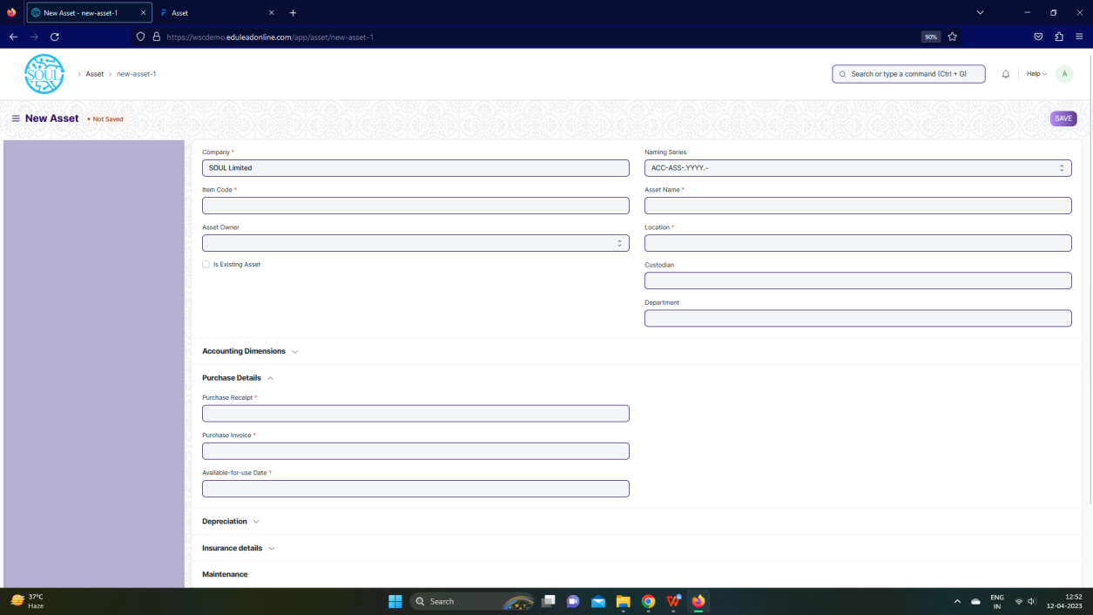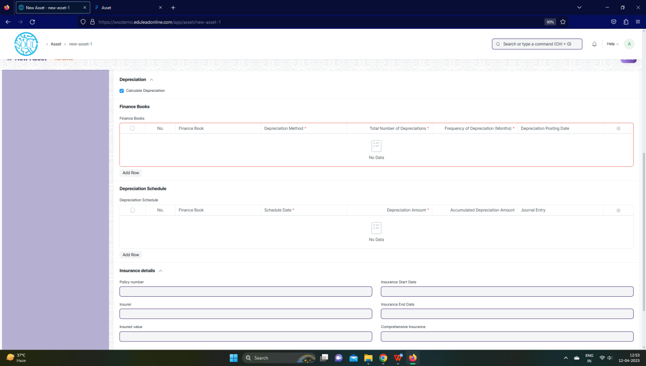

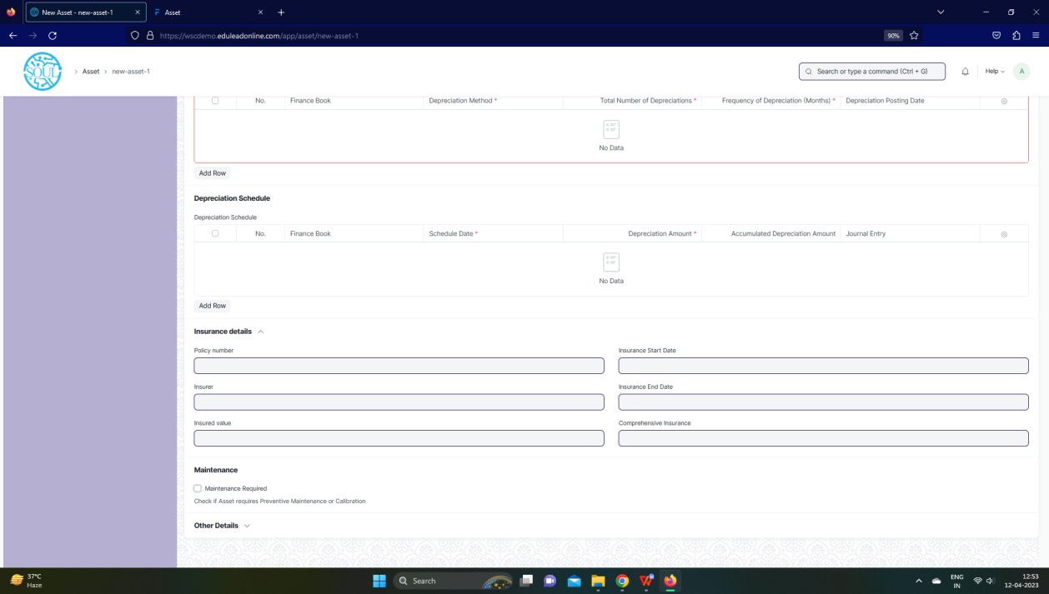

Fig: Asset Screen

**UI Fields**

The “Asset” screen shall consist of the following fields:

|  |  |  |  |  |  |  |  |  |  |
| --- | --- | --- | --- | --- | --- | --- | --- | --- | --- |
| **Field Label** | | | **Field Type** | | | **Validation/ Action** | **Mandatory** | **Remarks** | **R/N/D** |
| Company | | | Link | | | Fetched from Company screen | Yes |  |  |
| Item Code | | | Link | | | Fetched from Company screen | Yes |  |  |
| Item Name | | | Read Only | | | Populated based on selection of Item code |  |  |  |
| Asset Owner | | | Dropdown | | | Company/  Supplier /  Customer |  |  |  |
| Asset Owner Company | | | Link | | | Fetched from Company screen |  |  |  |
| Is Existing Asset | | | Checkbox | | | User Input |  |  |  |
| Supplier | | | Link | | | Fetched from Supplier screen |  |  |  |
| Customer | | | Link | | | Fetched from Customer screen |  |  |  |
| Image | | | Attach Image | | | User Input |  |  |  |
| Naming Series | | | Dropdown | | | ACC-ASS-.YYYY.- |  |  |  |
| Asset Name | | | Text Field | | | User Input | Yes |  |  |
| Asset Category | | | Link | | | Fetched from Asset Category screen |  |  |  |
| Location | | | Link | | | Fetched from Location screen | Yes |  |  |
| Custodian | | | Link | | | Fetched from Employee screen |  |  |  |
| Department | | | Link | | | Fetched from Department screen |  |  |  |
| Disposal Date | | | Date | | | User Input |  |  |  |
| Address | | | Link | | | Fetched from Address screen |  |  |  |
| Cost Center | | | Link | | | Fetched from Cost Center screen |  |  |  |
| Purchase Receipt | | | Link | | | Fetched from Purchase Invoice screen |  |  |  |
| Purchase Invoice | | | Link | | | Fetched from Purchase Invoice screen |  |  |  |
| Available-for-use Date | | | Date | | | User Input | Yes |  |  |
| Gross Purchase Amount | | | Currency | | | User Input | Yes |  |  |
| Asset Quantity | | | Int | | | User Input |  |  |  |
| Purchase Date | | | Date | | | User Input | Yes |  |  |
| Calculate Depreciation | | | Checkbox | | | User Input |  |  |  |
| Opening Accumulated Depreciation | | | Currency | | | User Input |  |  |  |
| Number of Depreciation's Booked | | | Int | | | User Input |  |  |  |
| **Finance Books** | | | **Table** | | | **These table is describe below** |  |  |  |
| Depreciation Method | | | Dropdown | | | Straight Line /  Double Declining Balance /  Manual |  |  |  |
| Value After Depreciation | | | Currency | | | User Input |  |  |  |
| Total Number of Depreciation's | | | Int | | | User Input |  |  |  |
| Frequency of Depreciation (Months) | | | Int | | | User Input |  |  |  |
| Next Depreciation Date | | | Date | | | User Input |  |  |  |
| **Depreciation Schedule** | | | **Table** | | | **These table is describe below** |  |  |  |
| Policy number | | | Text Field | | | User Input |  |  |  |
| Insurer | | | Text Field | | | User Input |  |  |  |
| Insured value | | | Text Field | | | User Input |  |  |  |
| Insurance Start Date | | | Date | | | User Input |  |  |  |
| Insurance End Date | | | Date | | | User Input |  |  |  |
| Comprehensive Insurance | | | Text Field | | | User Input |  |  |  |
| Maintenance Required | | | Checkbox | | | User Input |  |  |  |
| Status | | | Dropdown | | | Draft /  Submitted /  Partially Depreciated /  Fully Depreciated /  Sold /  Scrapped /  In Maintenance /  Out of Order /  Issue /  Receipt /  Capitalized /  Decapitalized |  |  |  |
| Booked Fixed Asset | | | Checkbox | | | User Input |  |  |  |
| Purchase Receipt Amount | | | Currency | | | User Input |  |  |  |
| Default Finance Book | | | Link | | | Fetched from Finance Book screen |  |  |  |
| Depreciation Entry Posting Status | | | Dropdown | | | Successful /  Failed |  |  |  |
| Manage | | | Button | | | Transfer Asset: On click of this button you can transfer Asset from One employee/Location to another |  |  |  |
| Scrap Asset: On click of this button you can scrap Asset |  |  |  |
| Sell Asset: On click of this button you can sell Asset |  |  |  |
| Maintain Asset: On click of this button you can create Maintenance schedule for an Asset |  |  |  |
| Repair Asset: On click of this button you can create repair details for an Asset |  |  |  |
| Split Asset: On click of this you can split Asset |  |  |  |
| Adjust Asset value: On click of this button you can see the value of Asset |  |  |  |
|  | | |  | | | View Ledger Entry: On click of this button you can view General entry for the Asset |  |  |  |
| **Finance Books (Child Table)** | | | | | | | | | |
| **Field Label** | | | | **Field Type** | | **Validation/ Action** | **Mandatory** | **Remarks** | **R/N/D** |
| Finance Book | | | | Link | | Fetched from Finance book screen |  |  |  |
| Depreciation Method | | | | Dropdown | | Straight Line /  Double Declining Balance /  Written Down Value /  Manual | Yes |  |  |
| Total Number of Depreciation | | | | Int | | User Input | Yes |  |  |
| Frequency of Depreciation (Months) | | | | Int | | User Input | Yes |  |  |
| Depreciation Posting Date | | | | Date | | User Input |  |  |  |
| Expected Value After Useful Life | | | | Currency | | User Input |  |  |  |
| Value After Depreciation | | | | Currency | | User Input |  |  |  |
| Rate of Depreciation | | | | Percent | | User Input |  |  |  |
| **Depreciation Schedule (Child Table)** | | | | | | | | |
| **Field Label** | **Field Type** | | | **Validation/ Action** | | **Mandatory** | **Remarks** | **R/N/D** |
| Finance Book | Link | | | Fetched from Finance book screen | |  |  |  |
| Schedule Date | Date | | | User Input | | Yes |  |  |
| Depreciation Amount | Currency | | | User Input | | Yes |  |  |
| Accumulated Depreciation Amount | Currency | | | User Input | |  |  |  |
| Journal Entry | Link | | | Fetched from Finance book screen | |  |  |  |
| Make Depreciation Entry | Button | | | On click of this button make depreciation entry for Asset | |  |  |  |
| Finance Book Id | Text Field | | | User Input | |  |  |  |
| Depreciation Method | DropDown | | | User Input | |  |  |  |

**Note:**

1. Asset report to be generated to differentiate between types of asset with remarks/comments
2. Stocks, Assets should be independent reports

**Users: Roles and Permissions**

The following table describes the users and their roles and permissions for the screens :

|  |  |  |  |  |  |  |  |  |  |
| --- | --- | --- | --- | --- | --- | --- | --- | --- | --- |
| **ID** | **Role** | **Select** | **Read** | **Write** | **Create** | **Delete** | **Submit** | **Cancel** | **Amend** |
|  | GM-Procurement & Contract Management | Yes | Yes | Yes | Yes | Yes | Yes | Yes | Yes |
|  | Purchase Manager | Yes | Yes | Yes | Yes | Yes | Yes | Yes | Yes |

### 1.2 Location

**General Description**

The Following table describe overall information about this screen:

|  |  |
| --- | --- |
| **Description :** | Asset Location shows where an Asset is located. |
| **Navigation :** | Home > Material Management > Assets > Location |
| **Pre-requisites :** | None |

**Location Screenshot**

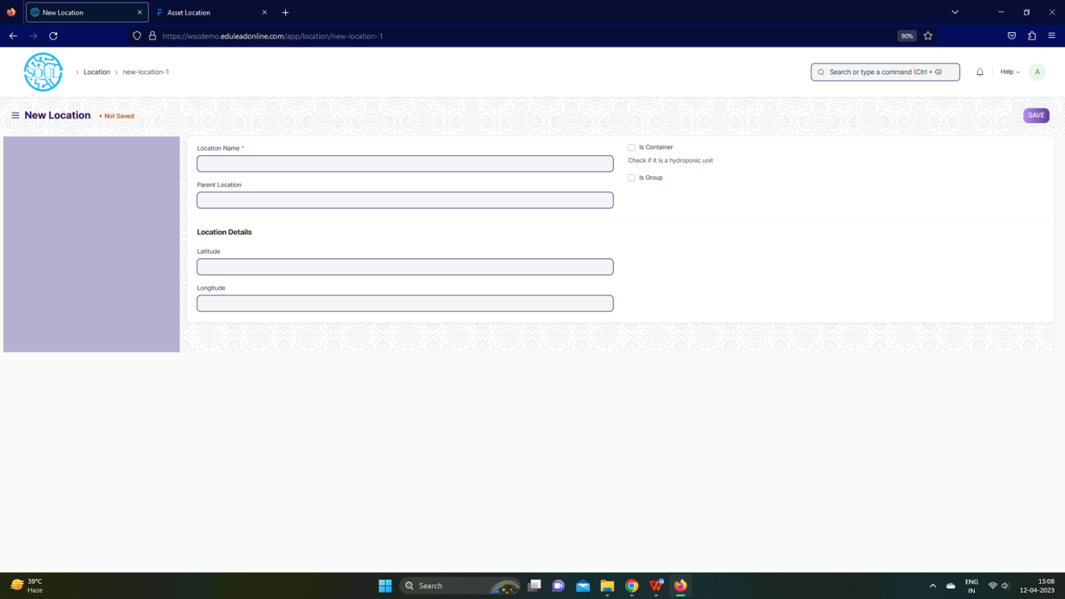

Fig: Location Screen

**UI Fields**

The “Location” screen shall consist of the following fields:

|  |  |  |  |  |  |
| --- | --- | --- | --- | --- | --- |
| **Field Label** | **Field Type** | **Validation/ Action** | **Mandatory** | **Remarks** | **R/N/D** |
| Location Name | Text Field | User Input | Yes |  |  |
| Parent Location | Link | Fetched from Asset Category screen |  |  |  |
| Is Container | Checkbox | User Input |  |  |  |
| Is Group | Checkbox | User Input |  |  |  |
| Latitude | Float | User Input |  |  |  |
| Longitude | Float | User Input |  |  |  |
| Area | Float | User Input |  |  |  |
| Area UOM | Link | Fetched from Asset Category screen |  |  |  |
| Location | Geo-location | User Input |  |  |  |

**Users: Roles and Permissions**

The following table describes the users and their roles and permissions for the screens :

|  |  |  |  |  |  |  |  |  |  |
| --- | --- | --- | --- | --- | --- | --- | --- | --- | --- |
| **ID** | **Role** | **Select** | **Read** | **Write** | **Create** | **Delete** | **Submit** | **Cancel** | **Amend** |
|  | GM-Procurement & Contract Management | Yes | Yes | Yes | Yes | Yes | Yes | Yes | Yes |
|  | Purchase Manager | Yes | Yes | Yes | Yes | Yes | Yes | Yes | Yes |

### 1.3 Asset Category

**General Description**

The Following table describe overall information about this screen:

|  |  |
| --- | --- |
| **Description :** | An Asset Category classifies different assets of a Company. |
| **Navigation :** | Home > Material Management > Assets > Asset Category |
| **Pre-requisites :** | None |

**Asset Category Screenshot**

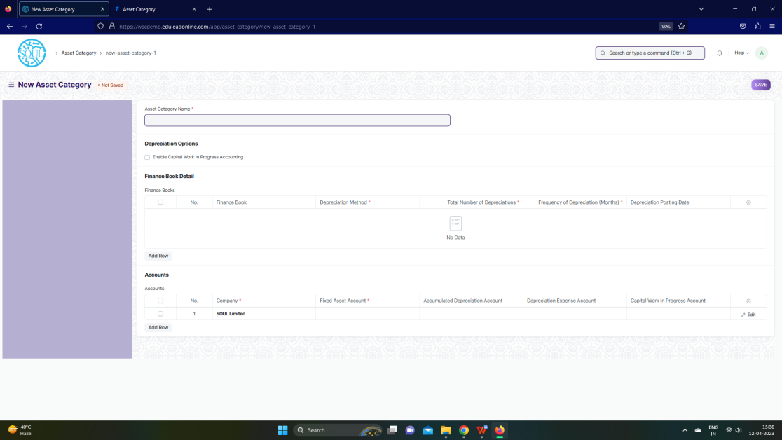

Fig: Asset Category Screen

**UI Fields**

The “Asset Category” screen shall consist of the following fields:

|  |  |  |  |  |  |
| --- | --- | --- | --- | --- | --- |
| **Field Label** | **Field Type** | **Validation/ Action** | **Mandatory** | **Remarks** | **R/N/D** |
| Asset Category Name | Text Field | User Input | Yes |  |  |
| Enable Capital Work in Progress Accounting | Checkbox | User Input |  |  |  |
| **Finance Books** | **Table** |  |  | These table is describe below |  |
| **Accounts** | **Table** |  | **Yes** | These table is describe below |  |
| **Finance Books (Child Table)** | | | | | |
| **Field Label** | **Field Type** | **Validation/ Action** | **Mandatory** | **Remarks** | **R/N/D** |
| Finance Book | Link | Fetched from Finance Book screen |  |  |  |
| Depreciation Method | Dropdown | Straight Line / Double Declining Balance / Written Down Value / Manual | Yes |  |  |
| Total Number of Depreciations | Int | User Input | Yes |  |  |
| Frequency of Depreciation (Months) | Int | User Input | Yes |  |  |
| Depreciation Posting Date | Date | User Input |  |  |  |
| Expected Value After Useful Life | Currency | User Input |  |  |  |
| Value After Depreciation | Currency | User Input |  |  |  |
| Rate of Depreciation | Percent | User Input |  |  |  |
| **Accounts(Child Table)** | | | | | |
| **Field Label** | **Field Type** | **Validation/ Action** | **Mandatory** | **Remarks** | **R/N/D** |
| Company | Link | Fetched from Company screen | Yes |  |  |
| Fixed Asset Account | Link | Fetched from Account screen | Yes |  |  |
| Accumulated Depreciation Account | Link | Fetched from Account screen |  |  |  |
| Depreciation Expense Account | Link | Fetched from Account screen |  |  |  |
| Capital Work In Progress Account | Link | Fetched from Account screen |  |  |  |

**Users: Roles and Permissions**

The following table describes the users and their roles and permissions for the screens :

|  |  |  |  |  |  |  |  |  |  |
| --- | --- | --- | --- | --- | --- | --- | --- | --- | --- |
| **ID** | **Role** | **Select** | **Read** | **Write** | **Create** | **Delete** | **Submit** | **Cancel** | **Amend** |
|  | GM-Procurement & Contract Management | Yes | Yes | Yes | Yes | Yes | Yes | Yes | Yes |
|  | Purchase Manager | Yes | Yes | Yes | Yes | Yes | Yes | Yes | Yes |

### 1.4 Asset Movement

**General Description**

The Following table describe overall information about this screen:

|  |  |
| --- | --- |
| **Description :** | Asset Movement refers to moving an Asset from one Location to another. |
| **Navigation :** | Home > Material Management > Assets > Asset Movement |
| **Pre-requisites :** | None |

**Asset Movement Screenshot**

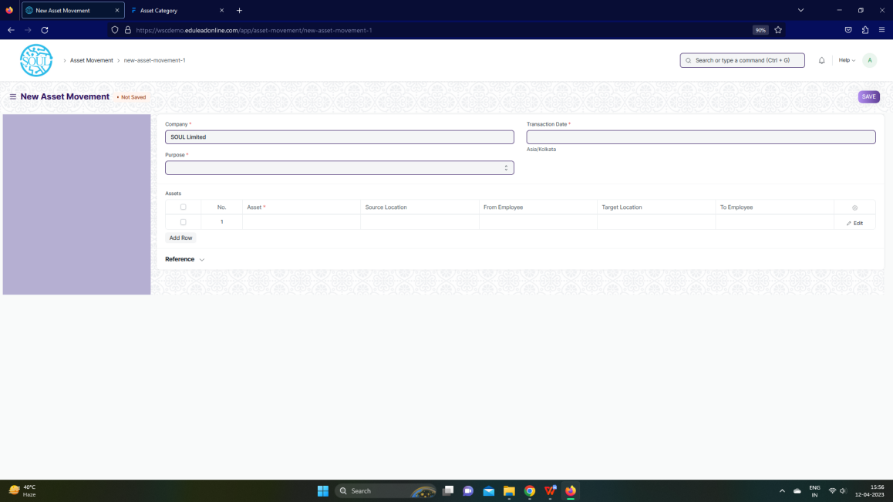

Fig: Asset Movement Screen

**UI Fields**

The “Asset Movement” screen shall consist of the following fields:

|  |  |  |  |  |  |  |  |
| --- | --- | --- | --- | --- | --- | --- | --- |
| **Field Label** | **Field Type** | **Validation/ Action** | **Mandatory** | | **Remarks** | | **R/N/D** |
| Company | Link | Fetched from Company screen | Yes | |  | |  |
| Purpose | Dropdown | Issue / Receipt /  Transfer | Yes | |  | |  |
| Transaction Date | Datetime | User Input | Yes | |  | |  |
| **Assets** | **Table** |  | Yes | | These table is describe below | |  |
| Reference Document Type | Link | Fetched from Doctype screen |  | |  | |  |
| Reference Document Name | Dynamic Link | Fetched from value in reference field |  | |  | |  |
| **Asset(Child Table)** | | | | | | | |
| **Field Label** | **Field Type** | **Validation/ Action** | | **Mandatory** | | **Remarks** | **R/N/D** |
| Company | Link | Fetched from Company screen | |  | |  |  |
| Asset | Link | Fetched from Asset screen | | Yes | |  |  |
| Source Location | Link | Fetched from Location screen | |  | |  |  |
| From Employee | Link | Fetched from Employee screen | |  | |  |  |
| Asset Name | Text Field | User Input | |  | |  |  |
| Target Location | Link | Fetched from Location screen | |  | |  |  |
| To Employee | Link | Fetched from Employee screen | |  | |  |  |

**Users: Roles and Permissions**

The following table describes the users and their roles and permissions for the screens :

|  |  |  |  |  |  |  |  |  |  |
| --- | --- | --- | --- | --- | --- | --- | --- | --- | --- |
| **ID** | **Role** | **Select** | **Read** | **Write** | **Create** | **Delete** | **Submit** | **Cancel** | **Amend** |
|  | GM-Procurement & Contract Management | Yes | Yes | Yes | Yes | Yes | Yes | Yes | Yes |
|  | Purchase Manager | Yes | Yes | Yes | Yes | Yes | Yes | Yes | Yes |

## Maintenance

### 2.1 Asset Maintenance Team

**General Description**

The Following table describe overall information about this screen:

|  |  |
| --- | --- |
| **Description :** | The Asset Maintenance Team is responsible for carrying out maintenance activities on the Asset. |
| **Navigation :** | Home > Material Management > Maintenance> Asset Maintenance Team |
| **Pre-requisites :** | 1. User 2. Role 3. Company |

**Asset Maintenance Team Screenshot**

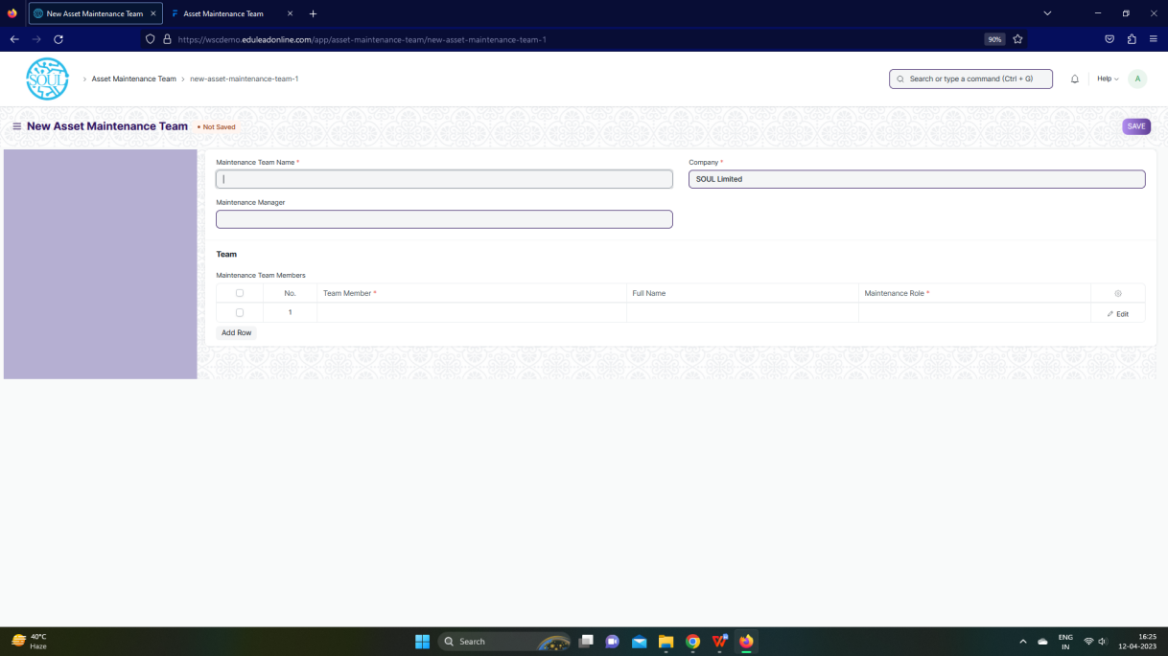

Fig: Asset Maintenance Team Screen

**UI Fields**

The “Asset Maintenance Team” screen shall consist of the following fields:

|  |  |  |  |  |  |  |
| --- | --- | --- | --- | --- | --- | --- |
| **Field Label** | **Field Type** | **Validation/ Action** | **Mandatory** | **Remarks** | **R/N/D** | |
| Maintenance Team Name | Text Field | User Input | Yes |  |  | |
| Maintenance Manager | Link | Fetched from User screen |  |  |  | |
| Maintenance Manager Name | Read Only | Fetched through Maintenance Manager |  |  |  | |
| Company | Link | Fetched from Company screen | Yes |  |  | |
| **Maintenance Team Members** | **Table** |  | Yes | These table is describe below |  | |
| **Maintenance Team Members(Child Table)** | | | | | | |
| **Field Label** | **Field Type** | **Validation/ Action** | **Mandatory** | **Remarks** | | **R/N/D** |
| Team Member | Link | Fetched from User screen | Yes |  |  | |
| Full Name | Text Field | User Input |  |  |  | |
| Maintenance Role | Link | Fetched from Role screen | Yes |  |  | |

**Users: Roles and Permissions**

The following table describes the users and their roles and permissions for the screens :

|  |  |  |  |  |  |  |  |  |  |
| --- | --- | --- | --- | --- | --- | --- | --- | --- | --- |
| **ID** | **Role** | **Select** | **Read** | **Write** | **Create** | **Delete** | **Submit** | **Cancel** | **Amend** |
|  | GM-Procurement & Contract Management | Yes | Yes | Yes | Yes | Yes | Yes | Yes | Yes |
|  | Purchase Manager | Yes | Yes | Yes | Yes | Yes | Yes | Yes | Yes |

### 2.2 Asset Maintenance

**General Description**

The Following table describe overall information about this screen:

|  |  |
| --- | --- |
| **Description :** | Asset Maintenance refers to any activity done on Assets to maintain their performance or condition. |
| **Navigation :** | Home > Material Management > Maintenance> Asset Maintenance |
| **Pre-requisites :** | 1. Asset 2. Asset Maintenance Team 3. Company |

**Asset Maintenance Screenshot**

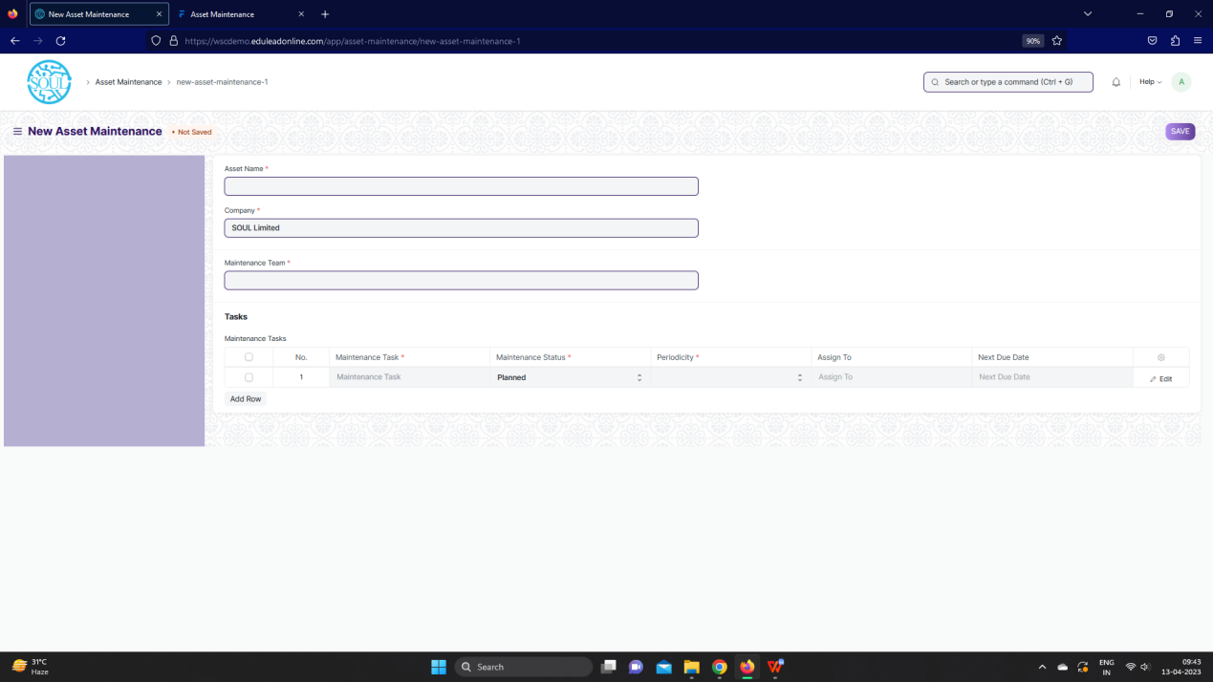

Fig: Asset Maintenance Screen

**UI Fields**

The “Asset Maintenance” screen shall consist of the following fields:

|  |  |  |  |  |  |  |
| --- | --- | --- | --- | --- | --- | --- |
| **Field Label** | **Field Type** | **Validation/ Action** | **Mandatory** | **Remarks** | | **R/N/D** |
| Asset Name | Link | Fetched from Asset screen | Yes |  | |  |
| Asset Category | Read Only | Fetched from selected asset |  |  | |  |
| Company | Link | Fetched from Company screen | Yes |  | |  |
| Item Code | Read Only | Fetched from selected asset |  |  | |  |
| Item Name | Read Only | Fetched from selected asset |  |  | |  |
| Maintenance Team | Link | Fetched from Asset Maintenance Team screen | Yes |  | |  |
| Maintenance Manager | Text Field | User Input |  |  | |  |
| Maintenance Manager Name | Read Only | Fetched from selected Asset Maintenance Team |  |  | |  |
| **Maintenance Tasks** | **Table** |  | **Yes** | These table is describe below | |  |
| **Maintenance Task (Child Table)** | | | | | | |
| **Field Label** | **Field Type** | **Validation/ Action** | | **Mandatory** | **Remarks** | **R/N/D** |
| Maintenance Task | Text Field | User Input | | Yes |  |  |
| Maintenance Type | Select | Preventive Maintenance /  Calibration | |  |  |  |
| Maintenance Status | Select | Planned / Overdue /  Canceled | | Yes |  |  |
| Start Date | Text Field | User Input | | Yes |  |  |
| Periodicity | Select | Daily / Weekly / Monthly /  Quarterly / Yearly / 2 Yearly | | Yes |  |  |
| End Date | Date | User Input | |  |  |  |
| Certificate Required | Checkbox | User Input | |  |  |  |
| Assign To | Link | Fetched from User screen | |  |  |  |
| Assign to Name | Read Only | Feted from value selected from Assign to value | |  |  |  |
| Next Due Date | Date | User Input | |  |  |  |
| Last Completion Date | Date | User Input | |  |  |  |
| Description | Text Editor | User Input | |  |  |  |

**Note:**

1. Asset Maintenance, mail to be triggered when the maintenance tasks / maintenance

log is being recorded

**Users: Roles and Permissions**

The following table describes the users and their roles and permissions for the screens :

|  |  |  |  |  |  |  |  |  |  |
| --- | --- | --- | --- | --- | --- | --- | --- | --- | --- |
| **ID** | **Role** | **Select** | **Read** | **Write** | **Create** | **Delete** | **Submit** | **Cancel** | **Amend** |
|  | GM-Procurement & Contract Management | Yes | Yes | Yes | Yes | Yes | Yes | Yes | Yes |
|  | Purchase Manager | Yes | Yes | Yes | Yes | Yes | Yes | Yes | Yes |

### 2.3 Asset Maintenance Log

**General Description**

The Following table describe overall information about this screen:

|  |  |
| --- | --- |
| **Description :** | Asset Maintenance Log logs the tasks carried out in an Asset Maintenance. |
| **Navigation :** | Home > Material Management > Maintenance> Asset Maintenance Log |
| **Pre-requisites :** | 1. Asset Maintenance |

**Asset Maintenance Screenshot**

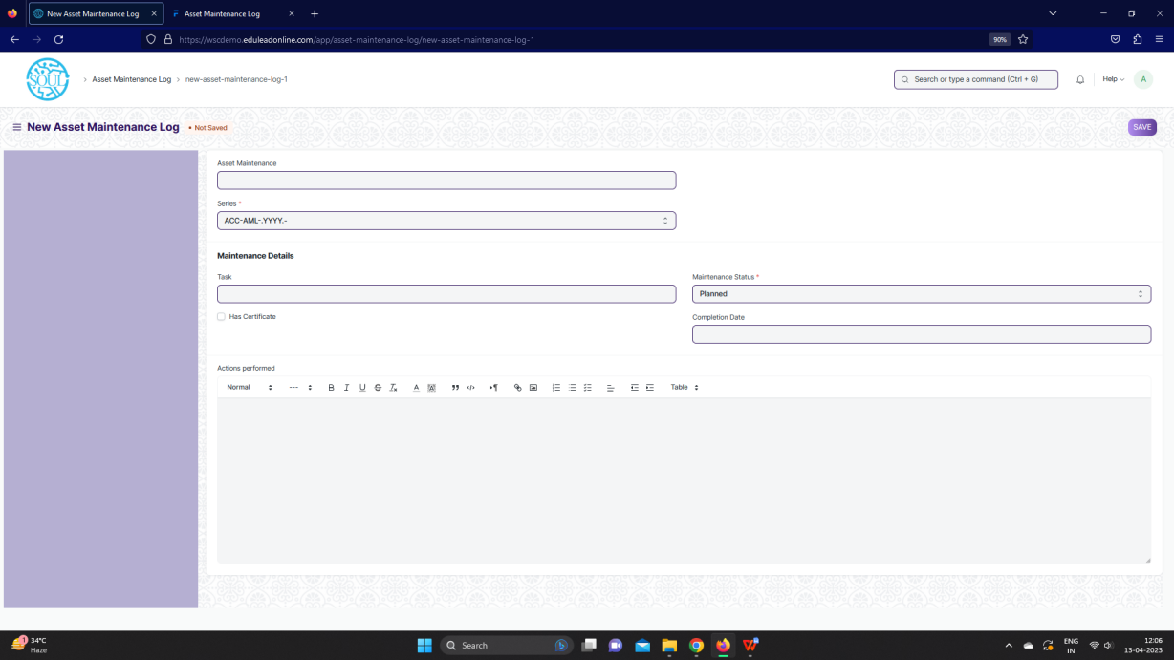

Fig: Asset Maintenance Log Screen

**UI Fields**

The “Asset Maintenance Log” screen shall consist of the following fields:

|  |  |  |  |  |  |
| --- | --- | --- | --- | --- | --- |
| **Field Label** | **Field Type** | **Validation/ Action** | **Mandatory** | **Remarks** | **R/N/D** |
| Asset Maintenance | Link | Fetched from Asset Maintenance screen |  |  |  |
| Series | Dropdown | ACC-AML-.YYYY.- | Yes |  |  |
| Asset Name | Read Only | Fetched from Asset Maintenance asset |  |  |  |
| Item Code | Read Only | Fetched from Asset Maintenance asset |  |  |  |
| Item Name | Read Only | Fetched from Asset Maintenance asset |  |  |  |
| Task | Link | Fetched from Task screen |  |  |  |
| Task Name | Text Field | User Input |  |  |  |
| Maintenance Type | Read Only | Fetched from Task asset |  |  |  |
| Periodicity | Text Field | User Input |  |  |  |
| Has Certificate | Checkbox | User Input |  |  |  |
| Certificate | Attach | User Input |  |  |  |
| Maintenance Status | Dropdown | Planned/ Completed /  Cancelled / Overdue | Yes |  |  |
| Assign To | Read Only | Fetched from Task asset |  |  |  |
| Due Date | Date | User Input |  |  |  |
| Completion Date | Date | User Input |  |  |  |
| Description | Read Only | Fetched from Task asset |  |  |  |
| Actions performed | Text Editor | User Input |  |  |  |

**Users: Roles and Permissions**

The following table describes the users and their roles and permissions for the screens :

|  |  |  |  |  |  |  |  |  |  |
| --- | --- | --- | --- | --- | --- | --- | --- | --- | --- |
| **ID** | **Role** | **Select** | **Read** | **Write** | **Create** | **Delete** | **Submit** | **Cancel** | **Amend** |
|  | GM-Procurement & Contract Management | Yes | Yes | Yes | Yes | Yes | Yes | Yes | Yes |
|  | Purchase Manager | Yes | Yes | Yes | Yes | Yes | Yes | Yes | Yes |

### 2.4 Asset Repair

**General Description**

The Following table describe overall information about this screen:

|  |  |
| --- | --- |
| **Description :** | Asset Repair refers to any activity carried to repair a broken Asset to restore full functionality. |
| **Navigation :** | Home > Material Management > Maintenance> Asset Repair |
| **Pre-requisites :** | 1. Asset |

**Asset Repair Screenshot**

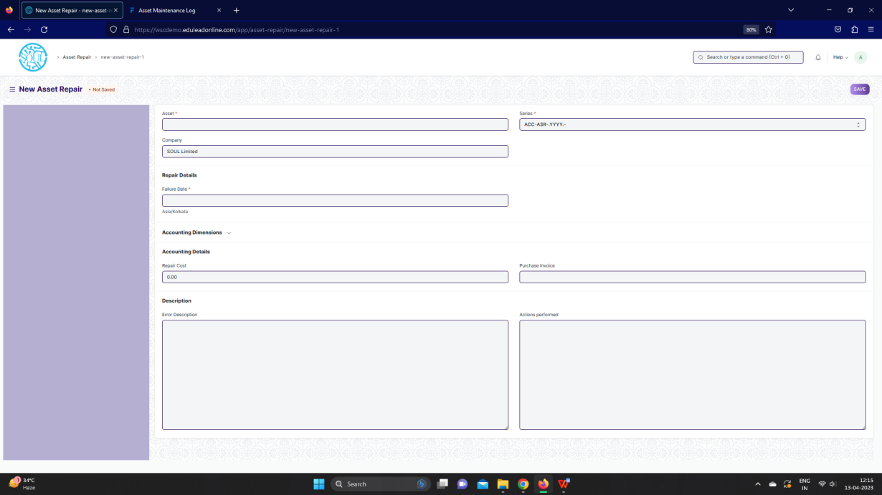

Fig: Asset Repair Screen

**UI Fields**

The “Asset Repair” screen shall consist of the following fields:

|  |  |  |  |  |  |  |  |  |  |
| --- | --- | --- | --- | --- | --- | --- | --- | --- | --- |
| **Field Label** | **Field Type** | | **Validation/ Action** | | **Mandatory** | | **Remarks** | | **R/N/D** |
| Asset | Link | | Fetched from Asset Maintenance screen | | Yes | |  | |  |
| Company | Link | | Fetched from Asset Maintenance screen | |  | |  | |  |
| Asset Name | Read Only | | Fetched from value in Asset field | |  | |  | |  |
| Series | Dropdown | | ACC-ASR-.YYYY.- | | Yes | |  | |  |
| Failure Date | Datetime | | User Input | | Yes | |  | |  |
| Repair Status | Dropdown | | Pending / ompleted /Cancelled | |  | |  | |  |
| Completion Date | Datetime | | User Input | |  | |  | |  |
| Address | Link | | Fetched from Address screen | |  | |  | |  |
| Article | Link | | Fetched from Article screen | |  | |  | |  |
| Cost Center | Link | | Fetched from Cost center screen | |  | |  | |  |
| Project | Link | | Fetched from Project screen | |  | |  | |  |
| Repair Cost | Currency | | User Input | |  | |  | |  |
| Capitalize Repair Cost | Checkbox | | User Input | |  | |  | |  |
| Stock Consumed During Repair | Checkbox | | User Input | |  | |  | |  |
| Purchase Invoice | Link | | Fetched from Purchase Invoice screen | |  | |  | |  |
| Warehouse | Link | | Fetched from Warehouse screen | |  | |  | |  |
| **Stock Items** | **Table** | |  | |  | | These table is describe below | |  |
| Total Repair Cost | Currency | | User Input | |  | |  | |  |
| Stock Entry | Link | | Fetched from Stock Entry screen | |  | |  | |  |
| Increase In Asset Life(Months) | Int | | User Input | |  | |  | |  |
| Error Description | Long Text | | User Input | |  | |  | |  |
| Actions performed | Long Text | | User Input | |  | |  | |  |
| Downtime | Text Field | | User Input | |  | |  | |  |
| View General Ledger | Button | | On click of the button you can General ledger for the Asset repair | |  | |  | |  |
| **Stock Items (Child Table)** | | | | | | | | | |
| **Field Label** | | **Field Type** | | **Validation/ Action** | | **Mandatory** | | **Remarks** | **R/N/D** |
| Item | | Link | | Fetched from Item screen | |  | |  |  |
| Valuation Rate | | Currency | | User Input | |  | |  |  |
| Consumed Quantity | | Text Field | | User Input | |  | |  |  |
| Total Value | | Currency | | User Input | |  | |  |  |
| Serial No | | Small Text | | User Input | |  | |  |  |

**Users: Roles and Permissions**

The following table describes the users and their roles and permissions for the screens :

|  |  |  |  |  |  |  |  |  |  |
| --- | --- | --- | --- | --- | --- | --- | --- | --- | --- |
| **ID** | **Role** | **Select** | **Read** | **Write** | **Create** | **Delete** | **Submit** | **Cancel** | **Amend** |
|  | GM-Procurement & Contract Management | Yes | Yes | Yes | Yes | Yes | Yes | Yes | Yes |
|  | Purchase Manager | Yes | Yes | Yes | Yes | Yes | Yes | Yes | Yes |